Matt’s CA Tutoring Tutorial

1. Open “Voxel Instructions” and skim through it with the “Voxel” program open and get to grips with the interface and what the buttons do.
2. Try experimenting with 1D CAs (press the 1S “1 Dimensional Step”) button on the left side of the window. Details how each rule acts from a single starting cell can be found here: <http://mathworld.wolfram.com/ElementaryCellularAutomaton.html> and how the rules are numbered and work can be found in Colin’s slides. Also try starting from more random conditions and note how sometimes the starting conditions can be just as important as the rules themselves. Some rules of note are 184 which can simulate traffic and rule 30 which creates some shell patterns found in nature (check Colin’s slides for more info)
3. Try loading in some of the example files and run them (File->Load). Many of these will give you 2D CA, and some will give you 1D, 2D step and even 3D. Some such as “Maze Generator” and “Cave System” can show some potential uses of CA while others just look cool.
4. Interact and draw with the mouse (hold ctrl and left click to draw and right click to erase) to create interesting starting conditions for any given CA. You may wish to do this on a smaller sized grid for better precision (note – only square/cube grids can be drawn on).
5. Try turning on Advanced Rules (in the options) and implementing “Game of Life” manually using only 3 rules. You will most likely need to reference the instructions for what numbers to put where and you can google the rules.

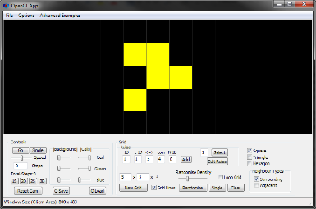

You can test it by making this shape (called a “glider”) and seeing if it moves across the grid

1. If you are feeling suddenly overwhelmed with a love for CA you may wish to save and share any nice looking CA you have made. Because you are just that cool. Also check out this link for some amazing examples of large scale Game of Life structures: <https://www.youtube.com/watch?v=C2vgICfQawE>
2. As a bonus: in honour of Colin’s invigorating talk on CAs, the Predator-Prey CA has been added to the “Advanced Examples” tab of the program (more info in the Colin’s slides). Another advanced example is a version of Schelling’s segregation model (rules explained below). Feel free to try them out and see these CAs in action.
3. Please complete the survey and send it to [11061359@students.southwales.ac.uk](mailto:11061359@students.southwales.ac.uk) and collect your chocolate (unless I forgot to buy them).

## Cat and Dog segregation model:

This model is a more PC version of Schelling’s segregation model which can demonstrate how quickly 2 different cell types can segregate with only a mild preference in their neighbours. The grid can be any size but will need around 30-10% of the grid to be empty. This is because cells cannot move to occupied locations. Think of empty cells as places where nothing lives, the rest of the grid will be randomly filled with coloured cells with either a cat (yellow) or a dog (red). During each step, every cell that is unhappy with where it lives will try to move to a new location where it will be happy.

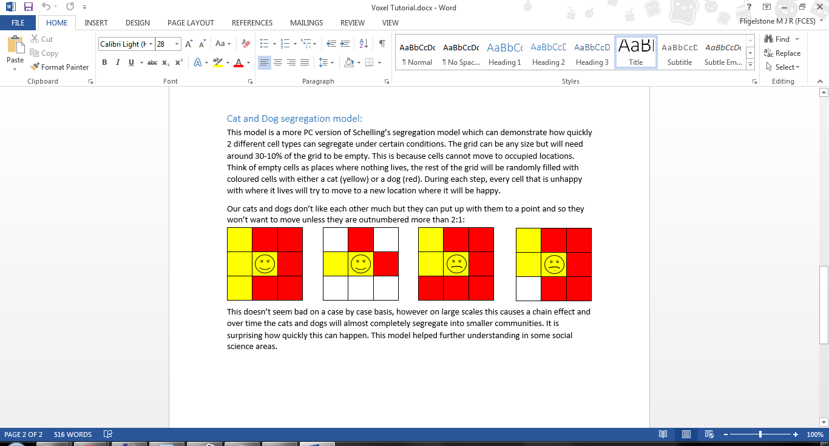Our cats and dogs don’t like each other much but they can put up with them to a point and so they won’t want to move unless they are outnumbered more than 2:1:

When a cat or dog wants to move, it will move to the nearest location that does not also suffer from the same conditions. This doesn’t seem bad on a case by case basis, however on large scales this causes a chain effect and over time the cats and dogs will almost completely segregate into smaller communities. It is surprising how quickly this can happen. This model can help further understanding in some social science areas.